Introduction
This functionality has been designed as an inbuilt tool for users to self manage a list of their most utilised screens. The main aim of the Favourites Menu is to enhance the speed of system navigation for users.

Favourites Menu Steps 1 and 2 to Create and Manage your personalised Favourites Menu
When users access their account the Tool bar will have a Favourites Menu; See below;

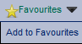

Step 1: “Add to Favourites”.
To add a screen to your Favourites Menu you will need to navigate to the required screen, click on the Favourites Menu and select “Add to Favourites”. The system will acknowledge your request and display a message as shown below;

Step 2:
When you access a screen that forms part of your Favourites Menu the menu will not have a selectable option to “Add to Favourites” it will be replaced with an option to “Remove from Favourites” see example below;
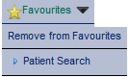
When you select “Remove from Favourites” the system will acknowledge your request and display a message as shown below;

Accesses the “Favourites” menu out with a patient record
When a user accesses the “Favourites” menu out with a patient record the only favourite options available to the user will be those that are of an administrative nature see example of main menu below as these are the option that would be available out with the user accessing a Clinical Patient Record.

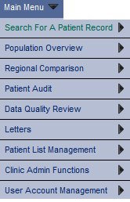

Accesses the “Favourites” menu with in a patient record
When a user has accesses a patient record all screens that have been selected previously as Favourites by the user will be made available as will those that are of an administrative nature. See example below of a users account within a patient record;
